|  |  |
| --- | --- |
| cid:2887E7B4-4235-4453-B7C9-14F4166BF0CB | Longridge Town Council  Council Offices, The Station Building  Berry Lane, Longridge, PR3 3JP  Telephone: **01772 782461**  email: [clerk@longridge-tc.gov.uk](http://h)  website: [www.longridge-tc.gov.uk](http://h) |

**Mission Statement**

Endeavour, through foresight and leadership, to enhance quality of life for Longridge residents and visitors.

Working to enrich facilities and nurture opportunity,

to protect and improve the built and natural environment, and promote community pride.

__________________________________________________________________________________________

Dear Councillor

You are invited to attend the Annual Meeting of Electors which is being held on Tuesday 21st May, 2019 at 7pm in the Civic Hall, Longridge.

The Agenda is set out below

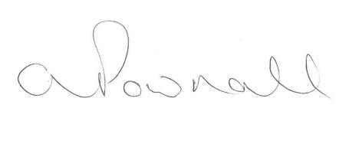

Andrea Pownall

Town Clerk

**AGENDA**

**1. Introductions by the Mayor**

**2. Approval of Minutes of the Annual Meeting of Electors held on 10th May 2018 by the electorate.**

**3. Items of Interest to the Electorate**

Guest Speakers

Review of last year and plans for the future

Achievements of the Longridge Community presented by Cllr. Stephanie Lomas

**4. Public Participation**

The electorate of Longridge are invited to bring their business to the meeting

**Please could the electorate ensure that the attendance sheet is completed (will be located in the entrance hall of the Civic Hall) before the commencement of the meeting to ensure that all business is addressed.**